November is Black Catholic History Month
Join us Sunday, Nov. 19th 10:00 – 11:00am

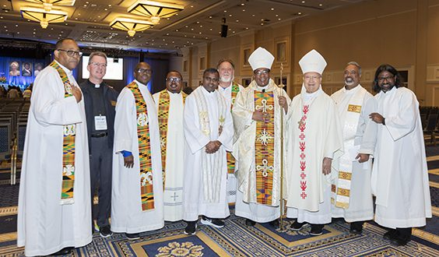
Did you Know……
- There are 3 million Black Catholics in the U.S.
- Among these are 250 priests, 5 bishops, 437 deacons, 400 religious sisters , 50 religious brothers, and 75 men in seminary formation.
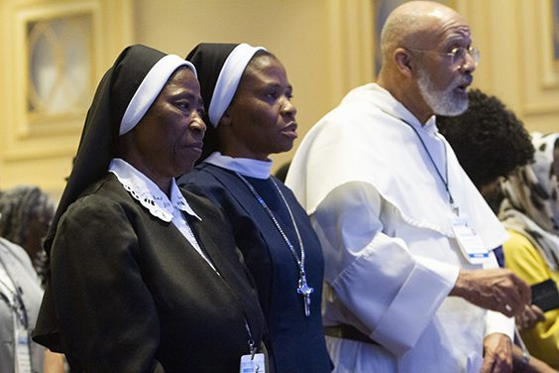
- The first Black Catholics Congress was held in 1889.
- The 13th Congress was held in Washington, D.C. in July ’23.
St. Edward’s Celebrates Black Catholic History on Nov. 19th.
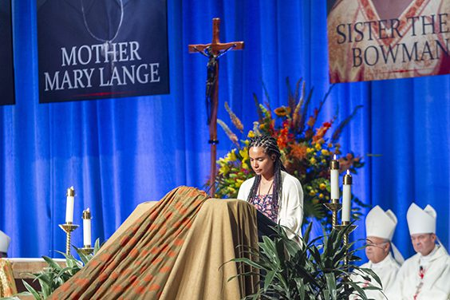
- A 34 minute video summary of the 13th Congress will be shown and discussed at St. Edward’s on Nov. 19.
- Join us at 9:45 am for snacks and refreshments in the Commons to learn about the rich faith traditions of Black Catholics.
- The video program will begin at 10am, with discussion following until 11am.
- Hosted by St. Edward’s Just Faith group.

